**Website Design and Development**

Regarding the technical progress of the project till now, we have developed and designed a website for the WaterTunnel Car Wash company. For developing websites, we deployed WordPress certified by Bitnami by using AWS web server involving several steps. The main reasons for choosing AWS cloud service for deploying WordPress are security and cost-effectiveness. When we completed the process of launching instances in EC2 we received a public IPv4 address and login username and password for the WordPress website.

Fig 3: Launching WordPress in AWS.

When creating websites then we collected different resources from online sources and some of them are designed by yourself. The website contains everything that needs to be a perfect website. The website is all about company’s information and car wash features. The website includes service details, Wash Menu, contact details etc. Here are some glimpses on our websites.

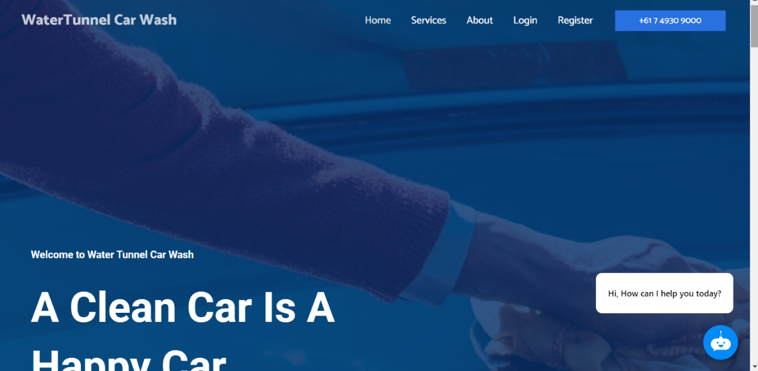

Fig 4: Company Website

Fig 5: Company Website